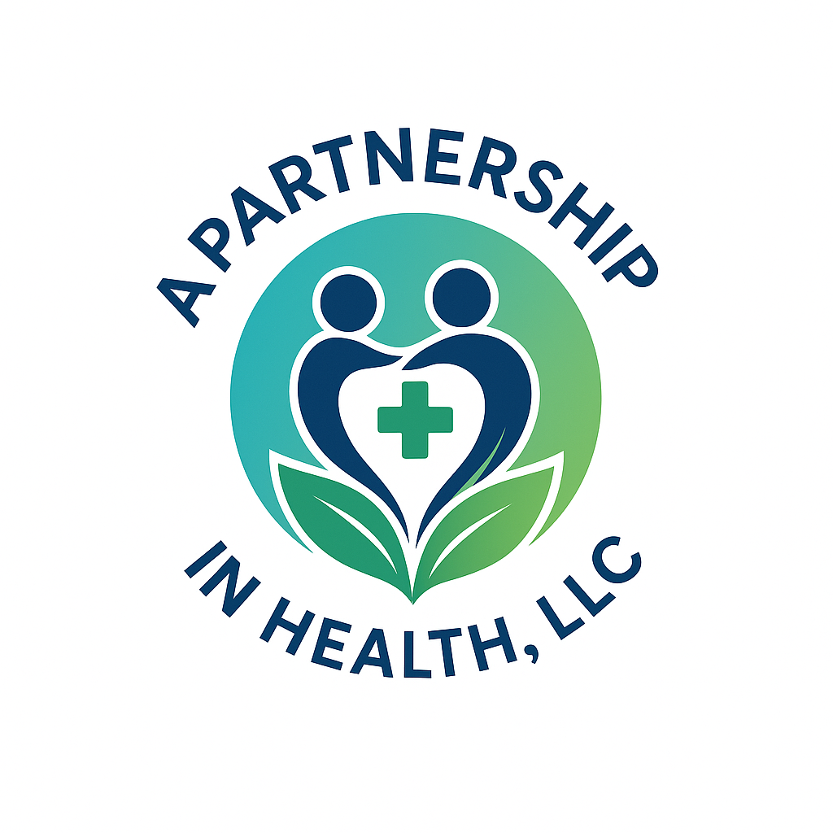
Document Submission Checklist
Please use this checklist to ensure all required documents and forms are submitted to A Partnership In Health, LLC. Check off each item as it is included and return this form along with your completed packet.
☐ Completed Client Intake Form
☐ Signed Credentialing Services Practice Agreement
☐ Provider’s Current CV or Resume
☐ Copy of Valid State Medical License
☐ Copy of DEA Certificate (if applicable)
☐ Board Certification (if applicable)
☐ Malpractice Insurance Certificate
☐ Completed Uniform Credentialing Application
☐ Completed Credentialing Supplemental Form
☐ Medicare Attestation Form (if applicable)
☐ HIPAA Compliance Acknowledgement Form
☐ CAQH Access Authorization Form
☐ Payment Authorization Form
☐ Completed Provider Roster or Provider Listing Form
☐ Any Additional Required Payer Forms
Please contact us at (336) 600-3262 or info@apartnershipinhealth.com with any questions.

